|  |
| --- |
| **Church News** My Church  New or newish to SWEC?  Pastor Pete and Karen would like to invite you to come over for supper at their house over two Tuesday evenings in May (1st and 8th at 8pm). This will be an excellent way to find out more about SWEC and how you can make this church your church. Free! To RSVP, contact them at pko@swec.org.au  Evangelism Workshop  We want to help you better talk to your friends about your faith and invite them to church.  Come along to our free evangelism workshop on Sat April 28 (9am-12.30pm) at Kingsgrove.  All experience and confidence levels will benefit from this.  For more info and to register see James Hoey or Grace Yam.  Support Gospel work at SWEC!  Generous financial partners are needed to help grow the ministry of Gospel work at SWEC.  Please consider partnering with SWEC by setting up electronic giving.  For information on how to set this up, email [give@swec.org.au](mailto:give@swec.org.au)  Community Groups  Want to know how your faith in Jesus interacts with your everyday life? Community groups are a great place to help you think through this. Meeting throughout the week on a regular basis, community groups are a great opportunity to help make sense of what it means to be a believer of Jesus in this world. For more information please email [communitygroups@swec.org.au](mailto:community@swec.org.au) |

**Upcoming Events**

April

28 - Evangelism workshop (9am-12:30pm Kingsgrove)

May

1, 8 - My Church - Newcomer's supper

2 – Prayer and Worship Night (7.45pm Kingsgrove)

6 – SWEC AGM (1-3pm, church hall)

19 - EQUIP women's conference (at venue - no live stream)

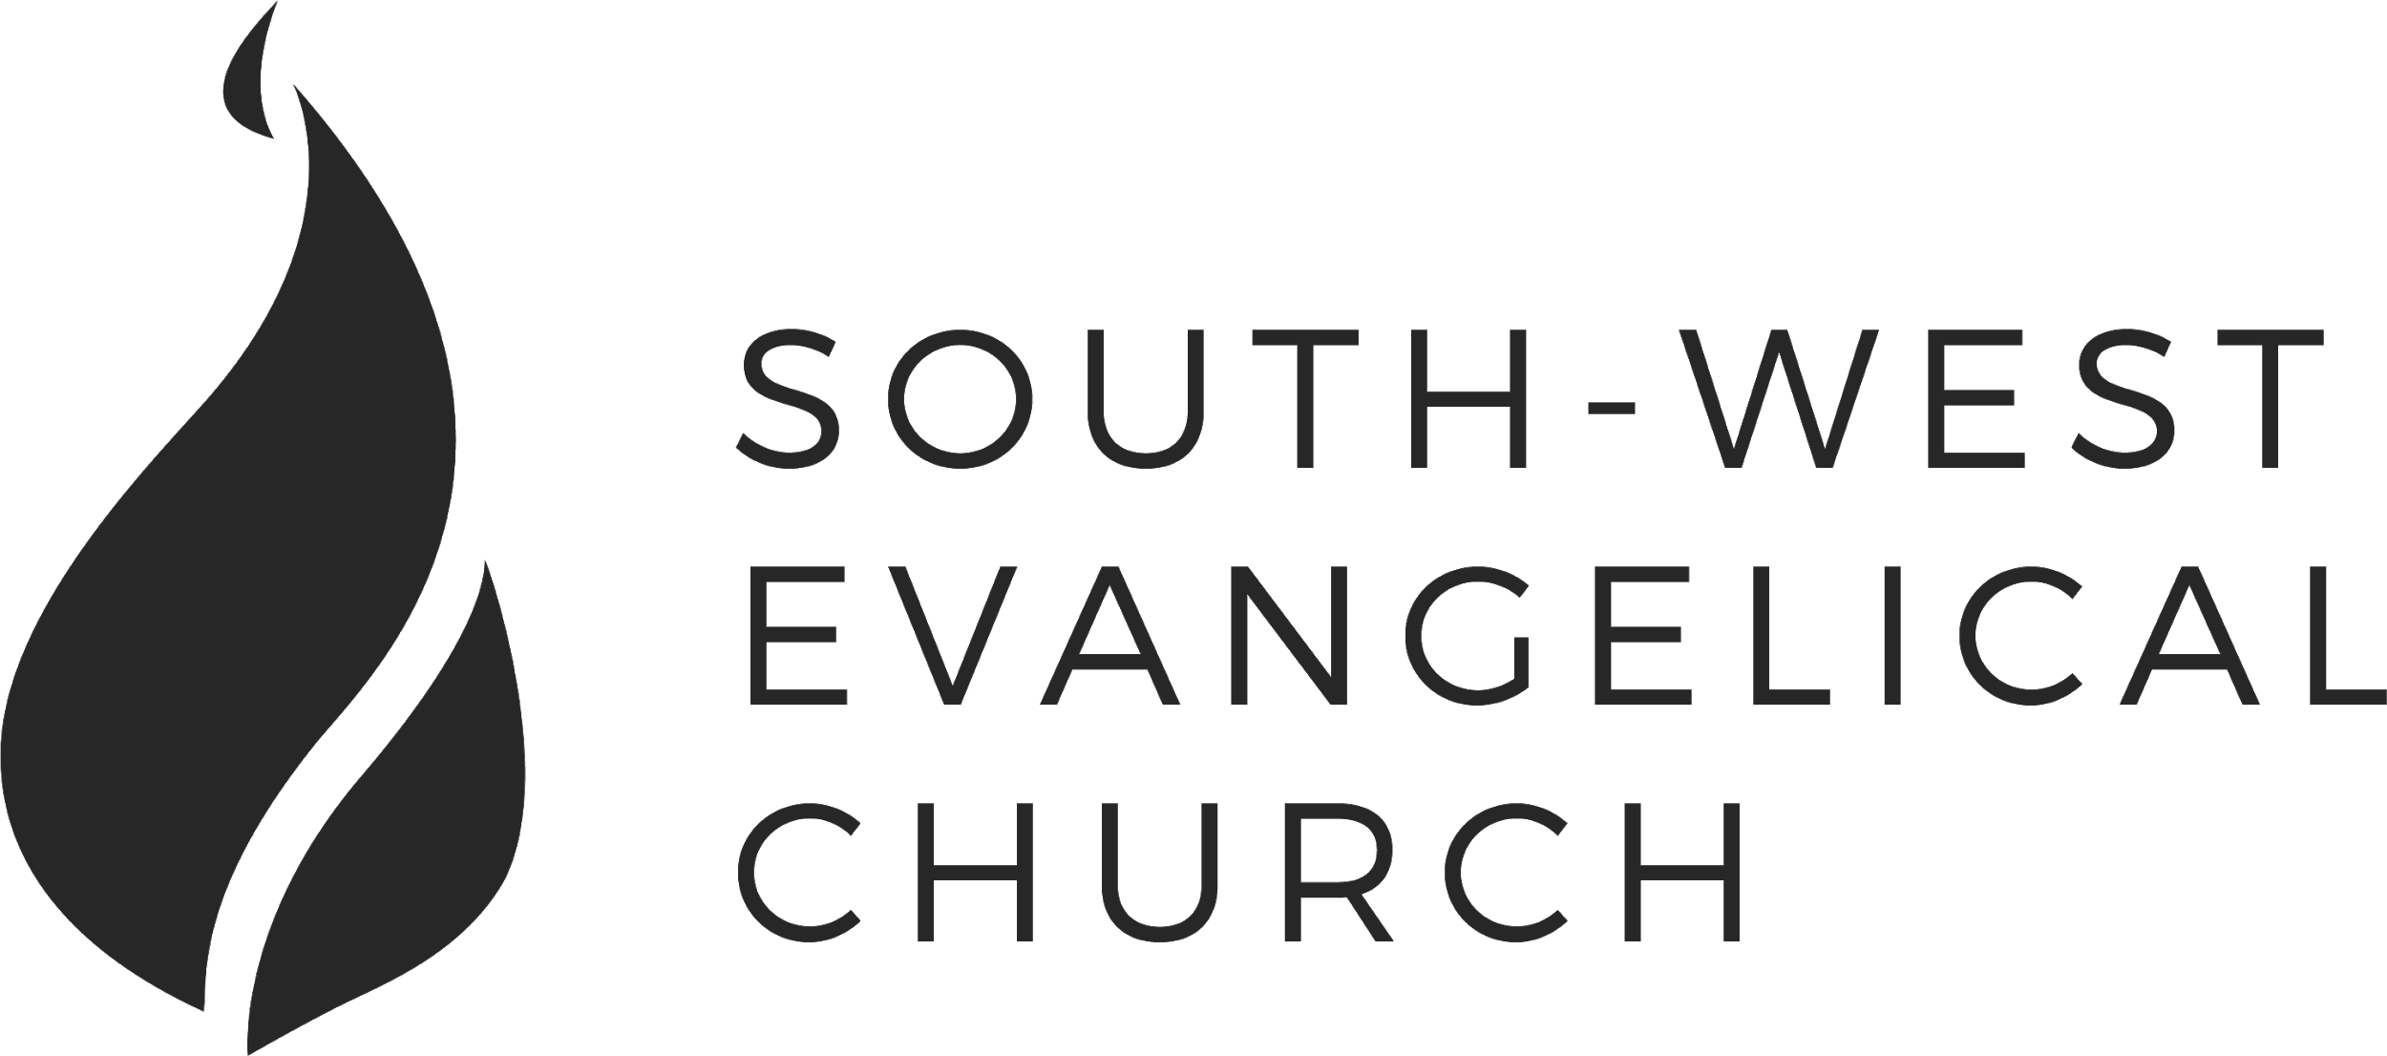

Sunday, 22 April 2018 | Bankstown | [www.swec.org.au](http://www.swec.org.au)

Pastor Dom Cheung | 0466 110 456 | dcheung@swec.org.au

What we’ll be doing during our time together

1. Worship

We’ll be worshipping God through song, prayer and by hearing His word.

Today’s confession prayer

Merciful God, our maker and our judge, we have sinned against you in thought, word, and deed:  
we have not loved you with our whole heart, we have not loved our neighbours as ourselves:  
we repent, and are sorry for all our sins.  
Father, forgive us.  
Strengthen us to love and obey you in newness of life;  
through Jesus Christ our Lord.  
Amen

Bible reading - Deuteronomy 4:32-35, 39-40

2. Community

An opportunity to get updated with what’s happening at SWEC!

3. Prayer

We’ll be praying for various needs in our church, the wider community, and the world.

4. God’s Word

Today’s sermon will be given by Dom Cheung.

5. Response

An opportunity for us to respond by singing, through holy communion, and by financial giving.

6. Blessing & Sending  
Go with God’s blessing to love and serve him and the world.

|  |  |  |
| --- | --- | --- |
| **Pastors**  Peter Ko (Lead Pastor)  Allan Mao  Stephen Fei  Dom Cheung  Karen Ko | **Elders**  Andrew Lim  Kirby Wong  Nelson Siu  board@swec.org.au | **Student Pastors**  Andrew Hayes  James Hoey  **Ministry Intern**  Lisa Truong |

Jesus vs The Bandaid of Religion

Mark 7:1-23

|  |
| --- |
|  |